**Performance Testing**

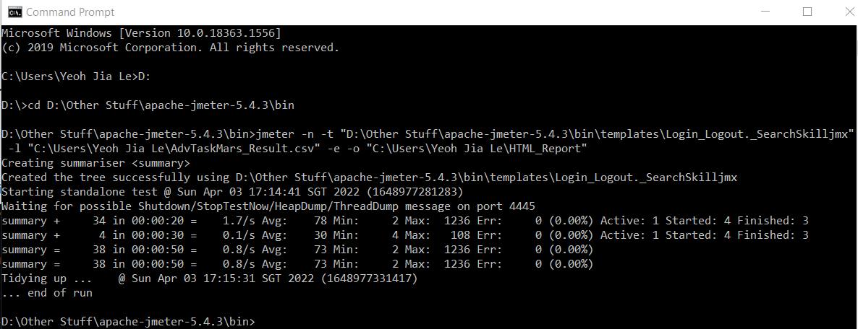

jmeter -n -t "D:\Other Stuff\apache-jmeter-5.4.3\bin\templates\Login_Logout._SearchSkilljmx" -l "C:\Users\Yeoh Jia Le\AdvTaskMars_Result.csv" -e -o "C:\Users\Yeoh Jia Le\HTML_Report"

**Test and Report Information of the performance testing**

